Tennis Tracker

User Guide



Submitted By: Ryan Williams

Submitted To: David Bishop

Email: [ryan.williams@oit.edu](mailto:ryan.williams@oit.edu)

Date: 5/16/2016

Version: 1.0

# Preface

This project is designed to be a tennis match tracking application for parents, coaches or players to track their matches. There are four main options. The first is to start a new match to track, which will prompt for a user to define what type of match is about to be played. The second is to give a log of the previous matches that were played and their point by point outcomes. The third is a focus point that the player should work on depending on the last few matches. The last is a chart of the errors that the player had in previous matches.

Contents

Preface 2

Feature Guide 4

Match Tracking 4

Previous Matches 6

Focus Point 6

Error Catalog 7

Troubleshooting Section 8

Known Errors 8

FAQ 8

Further Help/ Contact Details 8

Glossary 8

# Feature Guide

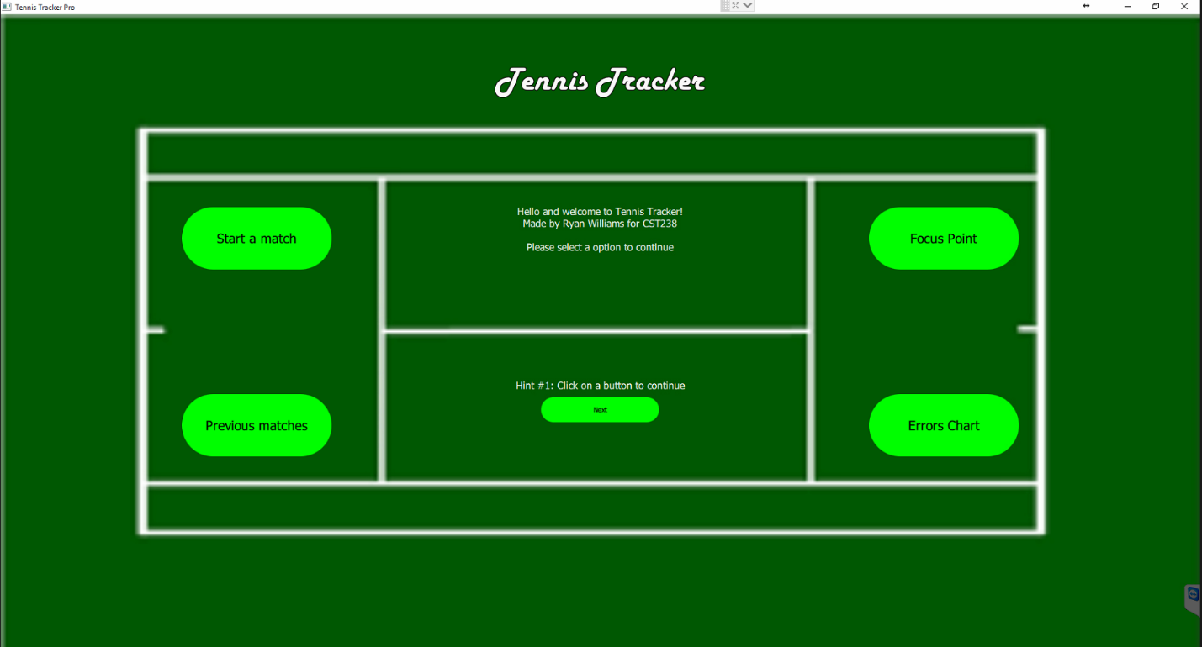

## Match Tracking

1. User should click start a match button
2. User should select the match settings according to the game that is being tracked

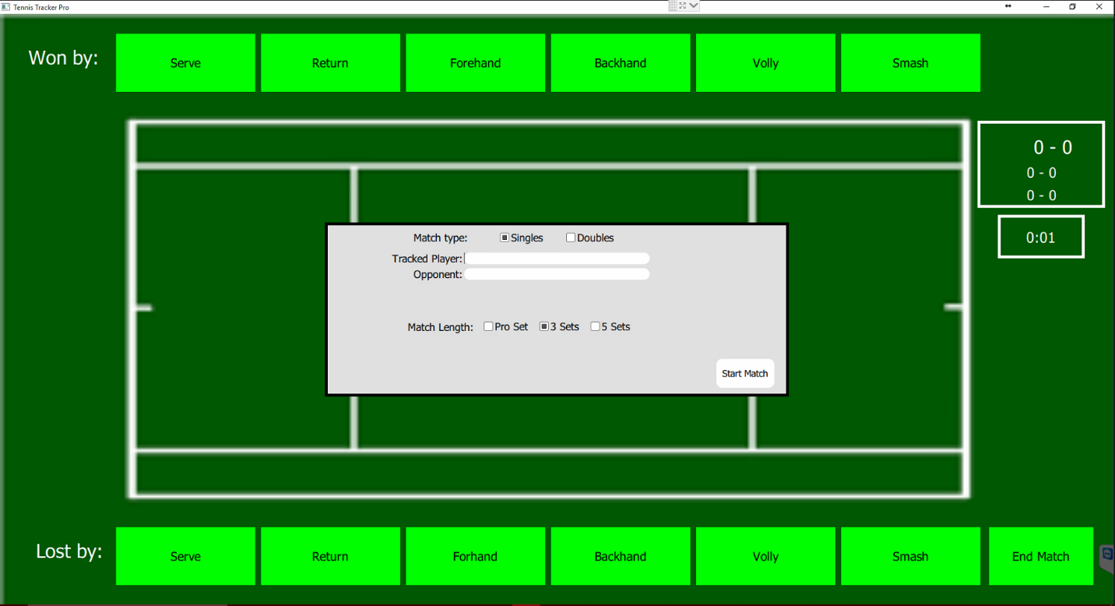

1. User clicks start game

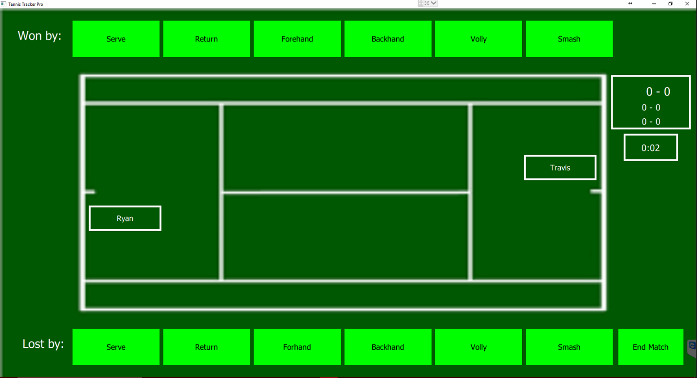

1. User clicks based on whether the tracked player wins or loses the point
2. When the match is over the app will prompt for it and end the match and return to the splash screen

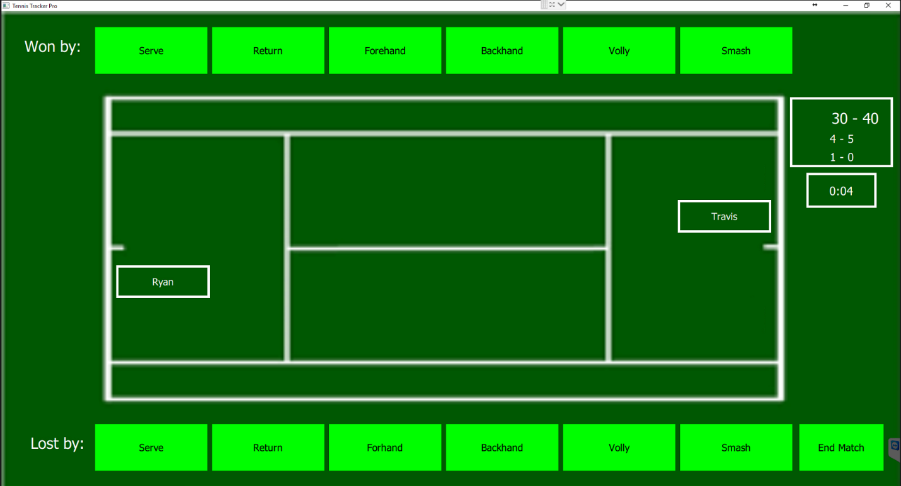

1. User can quit the match at any time to cancel the current match tracking. This will return the user to the splash screen.

## Previous Matches

1. Click the match catalog button to access the page
2. Page will display a chart or previous matches and their point by point break down of the match
3. User should click the buttons on the side to go to previous or next matches

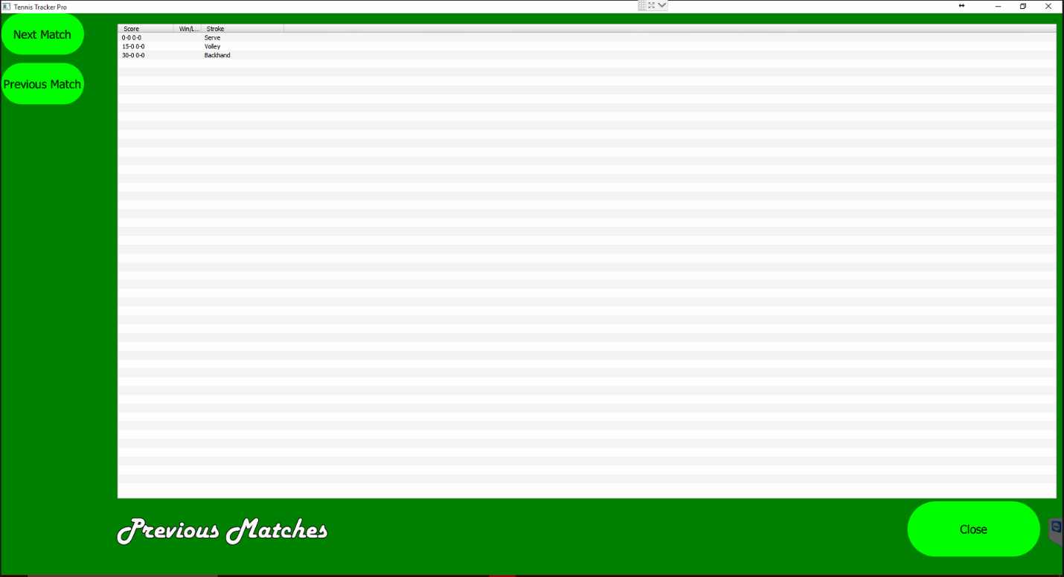

1. User should click back button leave the page

## Focus Point

1. Click the focus point button to access the page
2. Page will display what stroke the player should focus on, based on previous matches

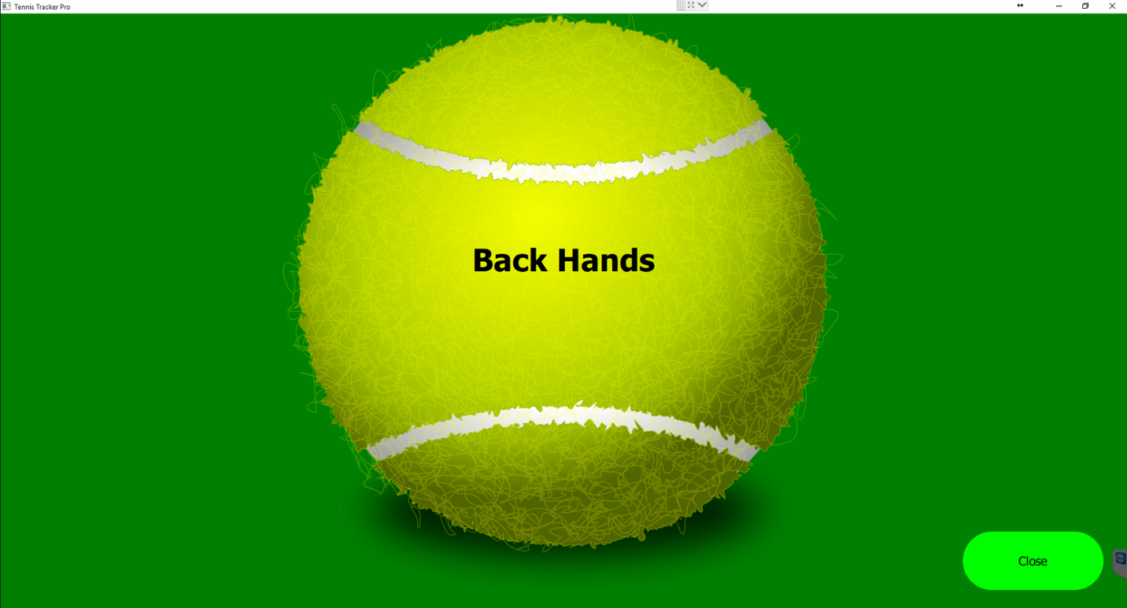

1. Click back button when wanting to exit back to the splash page

## Error Catalog

1. Click the error chart button to access the chart
2. View the error chart
3. Click back button when wanting to exit back to the splash page

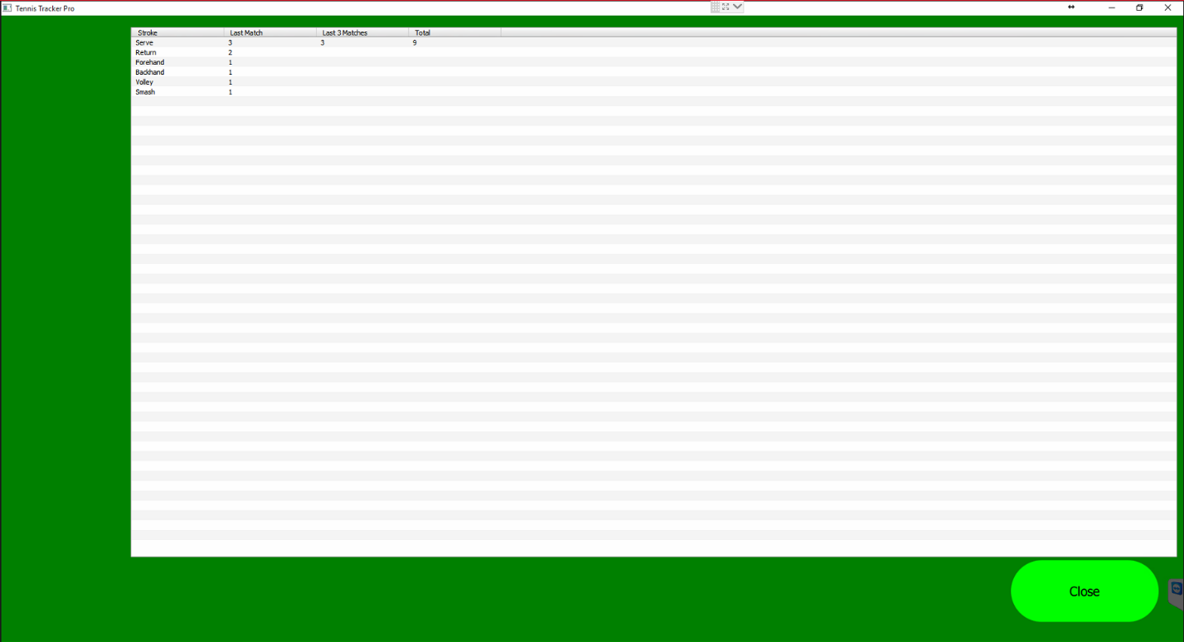

# Troubleshooting Section

## Known Errors

* Match time does not reset- please close the application and restart it if this occurs

# FAQ

**Q:** Does this program track both players separately for a double match?

**A:** No it does not, it will just add to the totals for the main tracked player of the program. Currently there is not a player profile implementation.

**Q:** How is focus point determined?

**A:** The stroke is determined based on the errors of the last 3 matches. By default it is set to backhands because that always seemed to be my personal focus point.

**Q:** Why is there a not a play based on Advantage option?

**A:** I developed this to be used for players in a USTA (United states tennis association) setting where their main rules of play do not include advantage based games.

# Further Help/ Contact Details

I, Ryan Williams, do not and will not support this product after release. Please use this program while knowing that I have no intention to provide assistance to the users.

# Glossary

**AD or Advantage**- Style a play that in each game a player must win by two points to win the game. For example if the score was 40-40 one player would have to win a point giving them the advantage, then another to give them the game point.